Technical Data Sheet

The blocking diode is for ensuring that the charging current flows from the main battery to the auxiliary battery if an auxiliary battery without a charger is connected in the vehicle. This means that the auxiliary battery is constantly charged and ready for operation even without an additional charger.

Installation

|  |  |
| --- | --- |
| info | Note!  To protect the charging cable, you must put an intermediate fuse before the battery's positive pole. Depending on the cable cross-section, you should use the following fuses: 16 amp for 1.5 mm² 25 amp for 2.5 mm² |

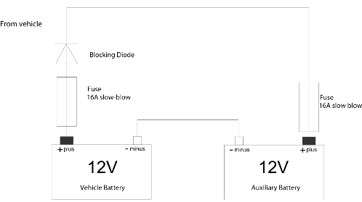

Blocking diode

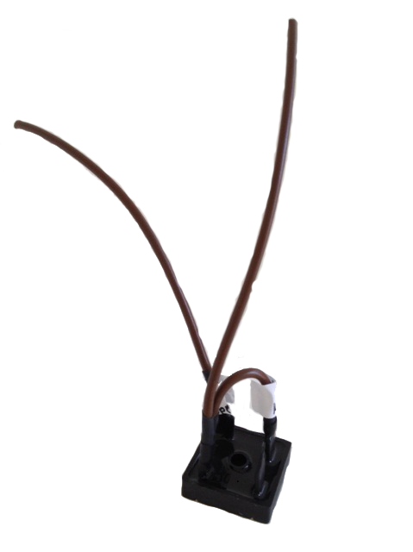

|  |  |
| --- | --- |
| info | Note!  Note that connected monitoring systems like Industrieelektronik Pölz GmbH's AkkuGuard, for example, do not detect a fuse failure.  If the fuse blows, charging is interrupted. |

Technical data

|  |  |
| --- | --- |
| Voltage | 12 V / 24 V |
| Dimensions  (W × H × D) | 270×100×130 mm |
| Weight | 41 g approx. |
| Item number | 30230 |

‘

This technical data sheet has been compiled to the best of our knowledge and belief. Duplication of these instructions or parts thereof by any reproduction method whatsoever is prohibited without the prior permission of Industrieelektronik Pölz GmbH. This technical data sheet does not constitute a document with contractual character. We reserve the right to make changes errors and omissions excepted. © Copyright 2017 Industrieelektronik Pölz GmbH

Central Office Office Germany:

Industrieelektronik Pölz GmbH IEP Pölz GmbH

Großendorf 122 Laufener Straße 59

4551 Ried im Traunkreis, Austria 83395 Freilassing, Germany

Tel.: +43 (0)7588 - 70 122 Tel.: +49 (0)8654 - 478 670

Fax: +43 (0)7588 - 70 125 Fax: +49 (0)8654 - 478 673

E-mail: [office@poelz.at](mailto:office@poelz.at) E-mail: office@poelz.at

Web: [www.poelz.at](http://www.poelz.at) Web: www.poelz.at